#
How to write a RESUME? What are the main parts of a good resume? What is the difference between a resume and a CV?
#
Give 10 terms with definitions related to your specialty.
#
Give 10 terms with definitions related to your specialty.
#
How to write an ARTICLE ABSTRACT? What should be included in this piece of academic work? What should be avoided? What is an APA style? What is a good abstract content?
#
How to write an academic essay? What is an argumentative essay? What is its structure? What parameters are taken into account while assessing an essay? What is good cohesion & coherence? What are logical connectives?
#
Speak about your professional activity. What are the strong and the weak points of your profession?
#
How to describe a graph, a bar chart, a pie chart? What is the structure and appropriate vocabulary?
#
How to describe a process? What is the structure and appropriate vocabulary?
#
Discuss. What is included in the sphere of Information Technologies? What is their role? Do they define our future?
#
Discuss. What is ergonomics? Is it important for a person’s productivity and safety at a workplace?
#
Discuss. Artificial Intelligence, virtual reality and robotics are likely to replace humans’ workforce in the future.
#
Discuss. The most important work-related issues. What are the major factors that define your choice of a job?
#
Discuss. Your short-term and long-term goals in your current or future profession.

#
Describe the graph below using appropriate vocabulary. Take into consideration the main trends

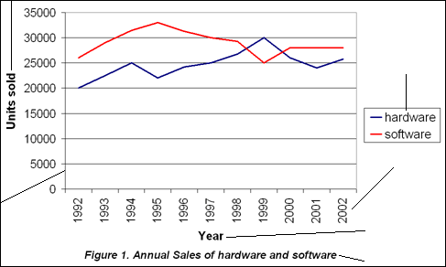

#
Describe the bar chart below using appropriate vocabulary. Take into consideration the main trends
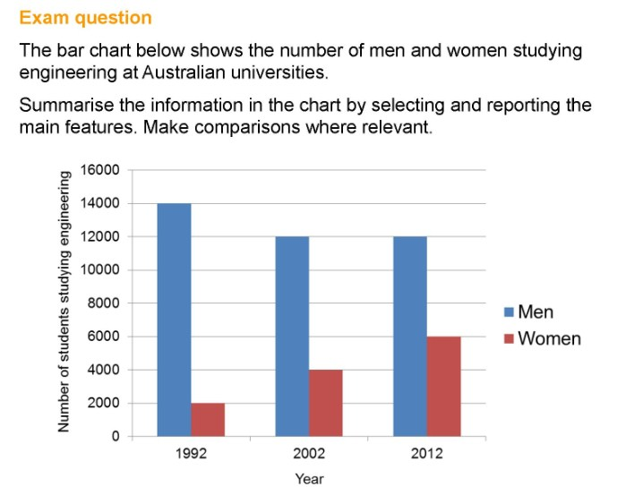
#
Describe the graph below using appropriate vocabulary. Take into consideration the main trends
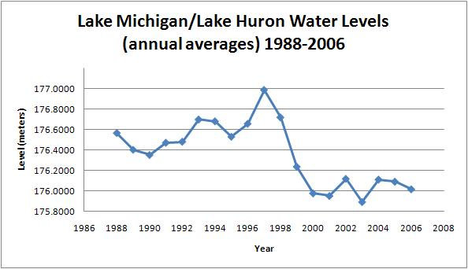
#
Describe the graph below using appropriate vocabulary. Take into consideration the main trends
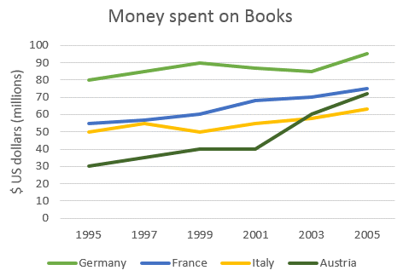
#
Describe the pie chart below using appropriate vocabulary. Take into consideration the main trends.
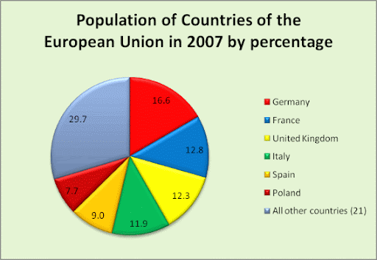

#
Describe the process of CONCRETE production using the figures below
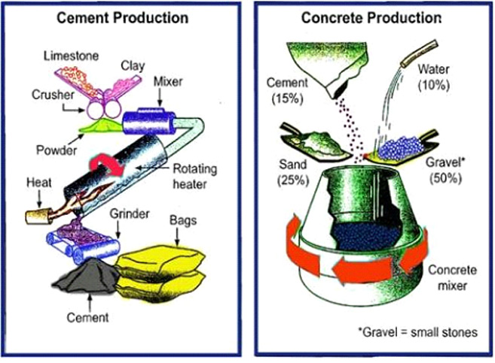
#
Describe the process of MILK production using the diagram below
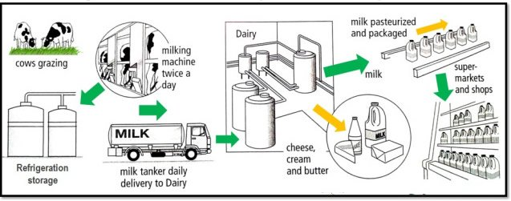
#
Describe the process of PAPER manufacturing using the diagram below
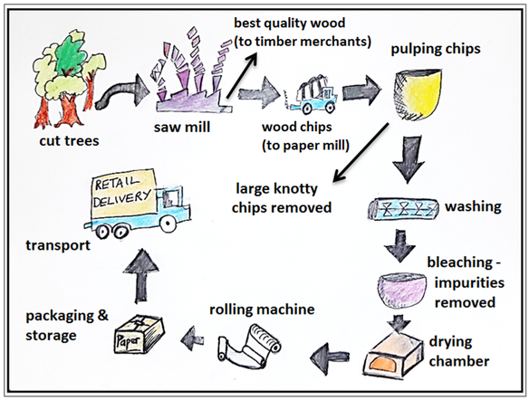
#
Give arguments for/against. Some people think that illegal Internet downloads are having a negative effect on the music industry. Others feel that they have little or no impact on artists. Discuss both views and give your own opinion.
#
Give arguments for/against. Successful sportsmen can earn a great deal more than people in other important professions. Some people think this is fully justified while others think it is unfair. Discuss both views and give your own opinion.
#
Give arguments for/against . Some people believe that in the near future there will be no borders between countries, while others feel that national borders will always remain. Discuss both views and give your own opinion.
#
Give arguments for/against . Some people feel that the media has the strongest impact on people’s lives. Others feel that it is politicians who have the most control over the way people lives. Discuss both views and give your own opinion.

#
Give arguments for/against . Some people think that economic development is the only way to end poverty while others believe that it is causing damage to the environment and so should be stopped. Discuss both views and give your opinion.

